

Economics (Part 1)

Course Summary

Marc Delingat

delingat@yahoo.com
http://www.geocities.com/delingat

Table of Contents
Table of Contents 2
Course Summary 3
Module 1: Economic Concepts, Issues, and Tools 3
Module 2: An Overview of Economics 4
Module 3: Demand 6
Module 4: Supply 8
Module 5: The Market 11
Module 6 Economic Efficiency 14
Module 7 Organization of Industries 15
Module 8: Public Goods and Externalities 17
Module 9: Income Distribution 19
Module 10: International Sector 21

Course Summary

Module 1: Economic Concepts, Issues, and Tools

Economics is the study of how individuals and nations use resources under their command to satisfy their wants as fully as possible or to maximize their welfare (or utility) given their resource constraints.
Engineering or Technical Efficiency describes the situation in which a good of stated quality is produced using the fewest possible resources.
Economic Efficiency the goods and services have to be produced in the most engineering efficient manner but also these goods and services have to be allocated so that the wants are satisfied as fully as possible.

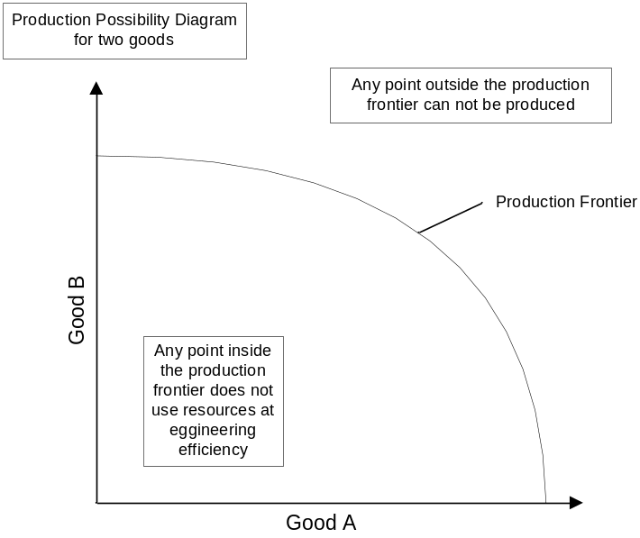

Marginal Benefit is the gain from an incremental change.
Marginal Cost is a loss associated with an incremental change.
Marginal Analysis examines the relationship between the cost and the benefit (utility) when applying incremental changes to the variable of which the effects are to be examined. It is used in economics frequently on maximization problems.

Scarcity Problem is defined as the dual existence of insatiable wants and limited resources for all societies that result in scarcity. Economies need to consequently make a choice what to produce with the limited resources available as resources used to satisfy one want are no longer available to satisfy other wants.

A resource is scarce whenever having more of it would make someone better off. In general, if there are unsatisfied wants, resources are scarce.

All nations no matter what political philosophy have to make the following economic choices:
- What goods and services to produce
- How to produce the selected goods and services
- To whom and in what share the goods and services are given

The scarcity problem can be resolved by
- Tradition
- Command
- Markets

Free goods are goods that are not scarce. The wants for free goods can be satisfied without the need for choice.

Opportunity cost is the “virtual” cost of the best (maximum utility) alternative that is/was not produced/picked/implemented for a given resource/activity. Essentially this is the benefit that one would have received if the next best alternative had been chosen.

Module 2: An Overview of Economics

Microeconomics is concerned with the behavior of particular items. Examples are the prices of meat vs. vegetables, the role of government taxes on private savings. International microeconomics is concerned with exports, imports, tariffs, and exchange rates. The basic theory used is the theory of demand and supply.

Macroeconomics is concerned with aggregates in the economy. Examples are the unemployment rate, control of money supply. International macroeconomics is concerned with balance of trade, balance of payments and the policy making to affect the exchange rate. The basic theory used is the theory of circular flows of national income.

Criticisms of the Market Economy
- Wrong goods and services
- The fallacy of the consumer sovereignty – consumers don’t vote with money, advertisers persuade consumers
- The pollution problem
- Poverty amongst plenty
- Inflation and unemployment

Externalities occur when the actions of an individual or firm confer benefits or costs on individuals or firms not directly involved in those actions.

Private Goods: A good bought and consumed for which the act of consumption affects no one else. Public Good: A good bought or owned that others can still consume without paying for it.
Economies of Scale arise when, as a firm’s level of output raises the unit cost of producing falls.

Monopolist is a firm that is the sole supplier of a certain good to a market. The price of the good will not reflects the cost of the goods used during production to the society, thus enabling the monopolist to earn above-normal profit. New entrants to the market that have access to the same resources to produce the good will be deterred since they would in the beginning not be able to achieve the same economies of scale and thus be at a disadvantage when trying to compete with the monopolist. To regulate a monopolist and influence the price collective action will be required, as the market has failed in this situation.
One criticism of the market economy is unequal income distribution. The income across the households can be depicted using the Lorenz Curve. In order to change an income distribution determined purely by market forces collective action is required.

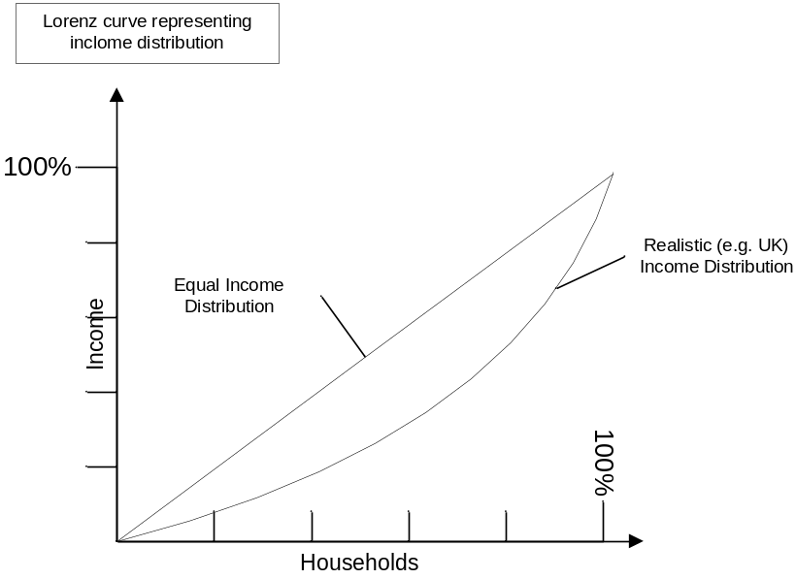

National Output (Y) = Consumption Expenditure (C) + Investment Expenditure (I) + Government Expenditure (G) + Net Exports (Exports – Imports)

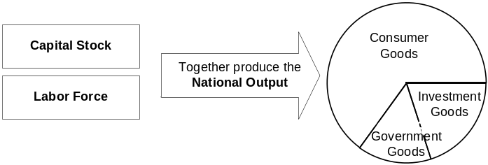

Idle Capital Stock and Unemployed Labor means that the economy is not producing the maximum possible national output and a portion of the “potential” national output is lost.

Investment goods are produced in order to achieve a higher standard of living in the future. That means consumers and firms are forfeiting fulfillment of current needs (utility) in the hope of achieving higher utility in the future.

Fiscal Policy is concerned with changing government expenditure and/or tax rates.
Monetary Policy is concerned with the changing of interest rates and/or the money supply.

Module 3: Demand

Equilibrium is reached when the last dollar spent on any good or service equals the utility received from every dollar spent on any other good or service.

Marginal Utility is the additional utility derived from consuming an additional unit of a given good.

The Law of Diminishing Marginal Utility states, that the marginal utility decreases as the consumption of a good increases.

Maximum Utility is derived when across all goods for a household (individual) the Marginal Utility (MU) in relation to the Price (P) is as follows:

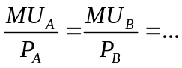

Individual Demand is represented in the relationship between the price and the quantity of a good that an individual would be willing to buy in a given time period (hypothetical relationship) ceteres pares (all other parameters equal). A typical demand curve is negatively inclined.

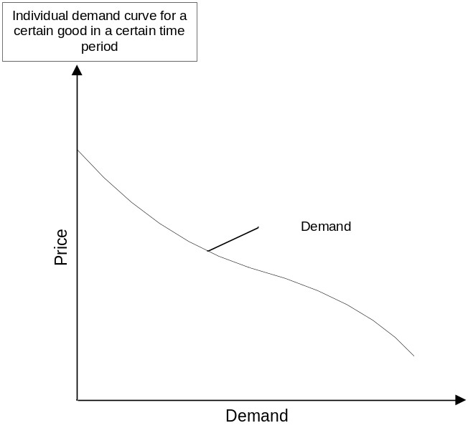

The Substitution Effect occurs when an individual substitutes a cheaper good for another good. The substitution effect is always negative: the increase of the price of a good will always lead to the substitution of relatively cheaper goods for that good.

The Income Effect can be described as follows: a higher price of a good X will, cet. par., lower an individual’s total utility because it decreases the quantities of goods that that he is able to purchase, i.e. he suffers a loss in real income.

An Inferior Good is a good for which the quantity that is sold falls when real incomes rise. A Giffen Good is a good for which at higher prices of the good a larger quantity is purchased. For a Giffen good the range of prices for which this relationship holds true is limited.

A shift of the demand curve can be caused by a change in any of the factors determining the position of the curve, e.g. income, prices of other goods, preferences. A movement along the demand curve is caused by a change in the price of the good.

A Market Demand curve is constructed by adding together the combined demand curves of all individuals in the market (along the demand axis).

Price Elasticity of Demand (Demand Elasticity) describes the sensitivity of the quantity of a good demanded in a market relative to price changes.

Demand Elasticity

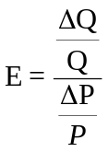

If E < 1 the demand for that good is called price-inelastic
If E > 1 the demand for that good is called price-elastic
E = 1 is called unitary price elasticity

Also used:
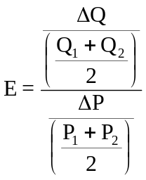

By using the average of the price and quantity as the base

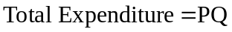

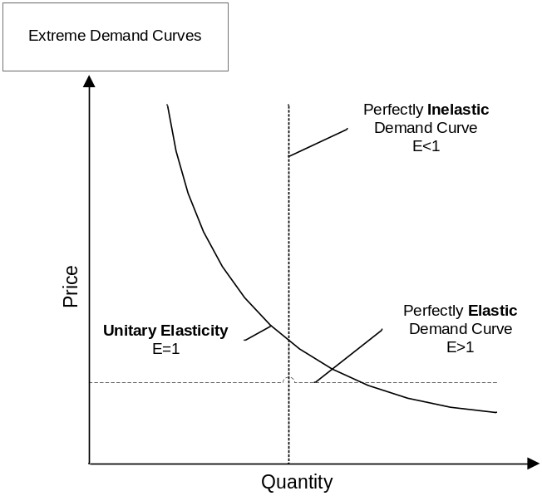
Cross Elasticity of Demand defines the change in demand of good B if the price of good A changes.

Cross Elasticity of Demand
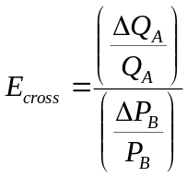

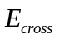< 0 for complementary goods
> 0 for substitute goods
= 0 shows that the goods are independent

Income Elasticity
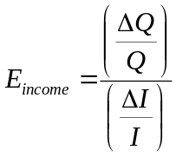
For an inferior good income elasticity is negative.

Module 4: Supply

The supply curve of a market can be constructed out of the summation of the individual supply curves of the companies in the market. A company’s supply curve is determined by its production curve.
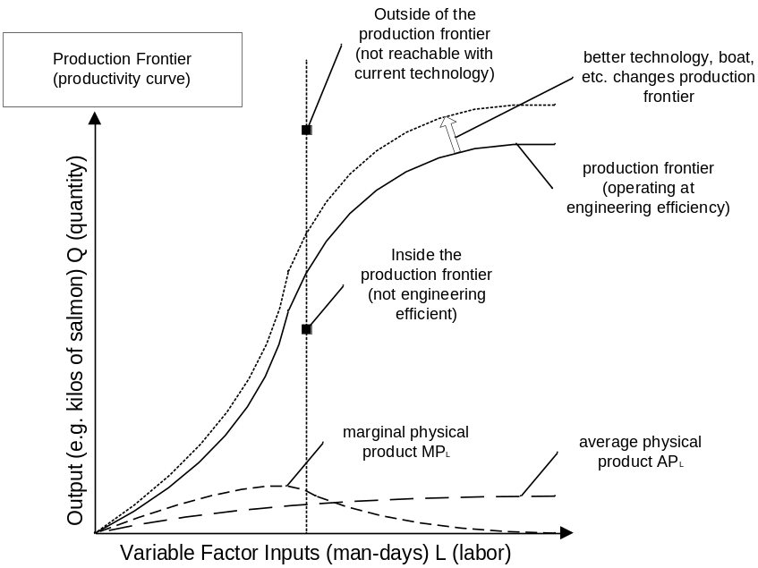

Average and Marginal Product of the Variable Factor Inputs
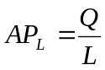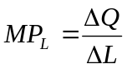

Resource Classification: Resources are classified either as capital or labor.

Total Cost (TC), Fixed Cost (FC), Variable Cost (VC), Average Total Cost (ATC)
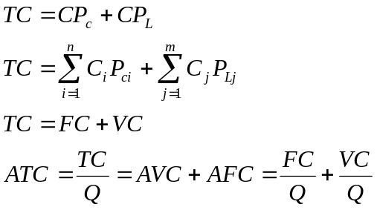

Fixed factors of production are certain factors of production that can not be practically altered in quantity in the short run. They can only be altered in the long run.
Variable factors of production can be altered in the short run (almost immediately).

Profit

Profit maximizing behavior of a company: A company with Marginal Revenue (MR) bigger than Marginal Cost (MC) will expand, as revenue will increase faster than cost. Similarly if MR<MC a company will reduce output as the cost are changing more than the revenue. Profit will be at a maximum where MR=MC.

If a perfectly competitive company were to maximize revenue, it would produce an infinite quantity of goods as revenue maximization does not take profit into account (an imperfectly competitive firm would produce until the marginal revenue was zero).
A perfectly competitive firm would produce at a level where ATC was at a minimum, however for a monopoly that might not be the case.

Assumptions for the following figure: Price is exogenous, cost of factor inputs is exogenous, one good only, and goal is profit maximization.

The average variable cost curve is constructed out of the average productivity per factor of labor input curve. (APL)

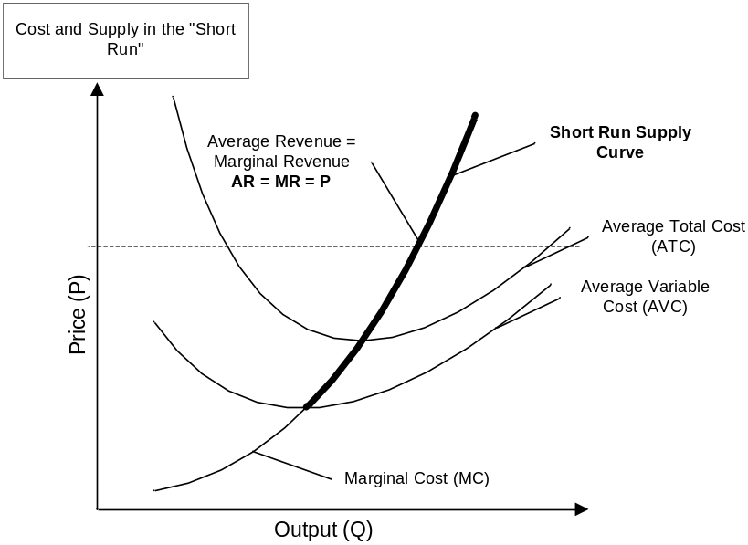
How does the behavior of a company change if the price changes in the short run?
- If the price were below the minimum of the Average Variable Cost, the company would produce nothing as the Average revenue (AR) equals price is below the average variable cost and thus it would just be cheaper to have no variable cost at all.
- As soon as the price is higher than the AVC, the company would output Q at which Marginal Cost MC equals the Marginal Revenue MR equals Price P.

Returns to factor inputs refer to varying one factor and holding all other factors constant and so is a short run phenomenon. Returns to scale refer to a change in output resulting from a change in all factor inputs and thus is a long run phenomenon.

Returns to factor inputs, Returns to scale
Increasing factor returns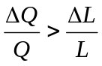 Increasing returns to scale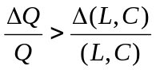
Diminishing factor returns 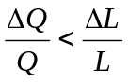 Increasing returns to scale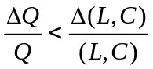

Price Elasticity of Supply (Supply Elasticity) describes the sensitivity of the quantity of a good supplied in a market relative to price changes.

Supply Elasticity

If E < 1 the supply for that good is called price-inelastic
If E > 1 the supply for that good is called price-elastic
E = 1 is called unitary supply elasticity

Also used:

By using the average of the price and quantity as the base

The long run supply curve of an industry with companies moving in and out of it is a horizontal line as long as the factor inputs are not affected. The long run supply curve is not affected by the supply curve of any current company in the industry. If the cost of factor inputs increases as more firms move into the industry, the long run supply curve will go up as the quantity produced grows.

The average labor productivity (AP_{L}) is calculated by dividing the output by the total number of workers.

Module 5: The Market

A market exists if potential buyers and sellers are in communication with each other. The characteristics of a perfect market are:
- Many buyers are sellers to ensure sufficient liquidity
- Perfect information on the market (e.g. asking price) and the goods and services to be traded
- Freedom of entry and exit to the market
- Homogenous product

If a price causes excess demand or excess supply to exist in a market, forces in the market will change the price and the quantity bought and sold until excess supply or excess demand is eliminated. A market is in equilibrium if the forces that act to eliminate excess demand or excess supply exactly offset each other; there is no excess demand and no excess supply.
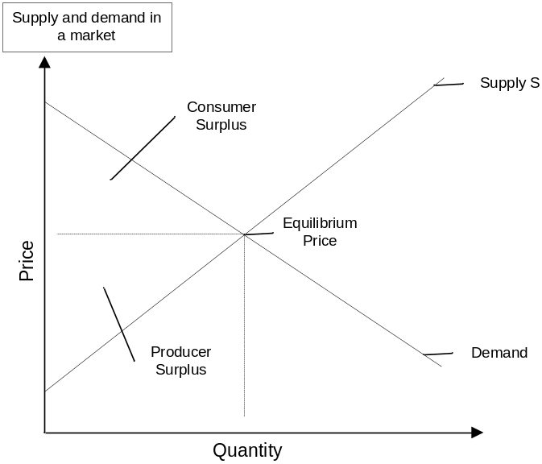
The consumer surplus is difference between the actual price paid and the (higher) price some consumers would be willing to pay. The producer surplus is the difference between the actual price received for a unit sold and the (lower) price producers would have been willing to sell for.

If a price ceiling exists the price of a certain good is not allowed to rise above a certain level. If the price has reached the price ceiling, price itself will not be sufficient to allocate the supply. Additional allocation mechanisms will have to be used. Usually if a price ceiling has been reached, a black market will tend to develop.
If a price floor exists the price of a certain good is not allowed to fall below a certain level. If the price has reached the price floor, price itself will not be sufficient to dispose off the additional supply. Additional disposal mechanisms for the excess supply will have to be found. Those could be: destruction of surplus, government purchase of surplus, selling of surplus in another market, pay the producer not to produce.

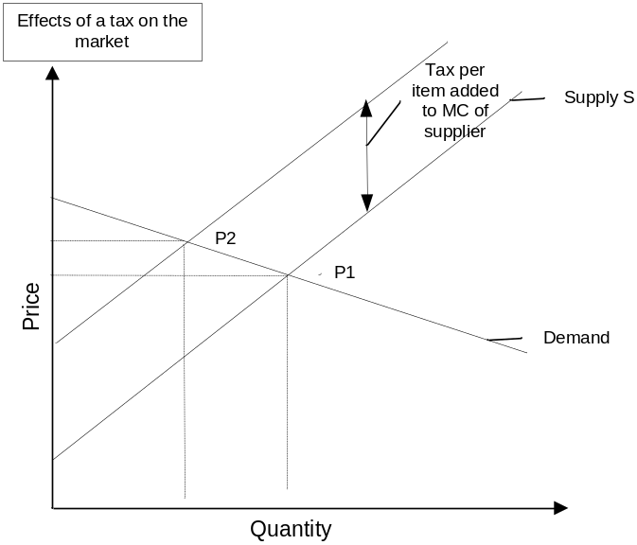

If a tax is imposed on every quantity of a good bought and sold, the consumer and the producer surplus will decrease. The imposition of a transaction tax affects the market supply curve through its input on the marginal cost of the producer, who will have to pay the cost to the government and thus will only be willing to supply each quantity for a price that is increased by the tax imposed. The final change in price and quantity sold depends on the elasticity of the supply and demand in the market. In general, the overall volumes of transactions will go down and thereby the overall gain from the exchange will decline. Subsidies work exactly the opposite way.

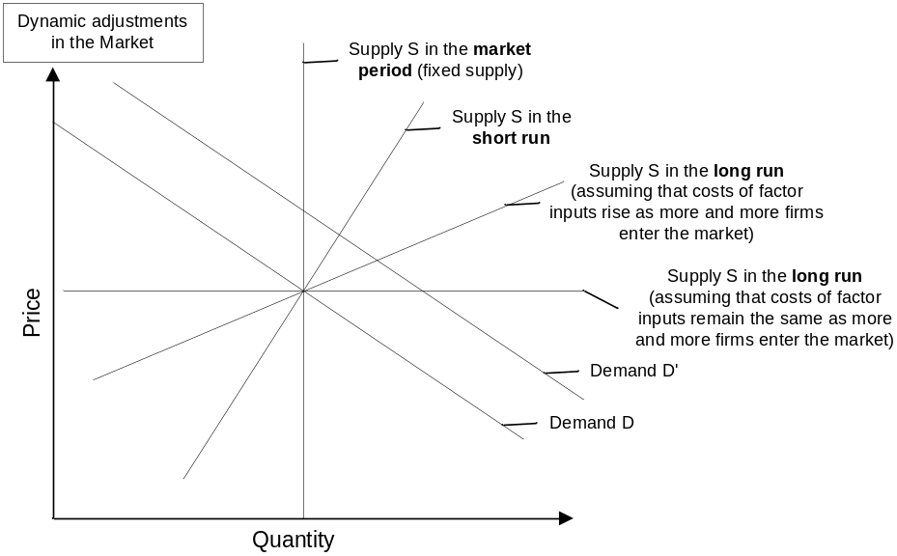

If there is a time lag in the change of the supply of a market in relation to the current price, a cyclical pattern can occur. Dependent on the relative slopes of the supply and demand curves the fluctuations in the market will converge or diverge from the equilibrium price. This dynamic behavior can be analyzed using a cobweb model. The model will converge if the supply curve is (in absolute terms) steeper than the demand curve. Only if the following assumptions hold true, is the cobweb model valid: Producers never learn from consumers, production is always adjusted, there are no speculators in the market.

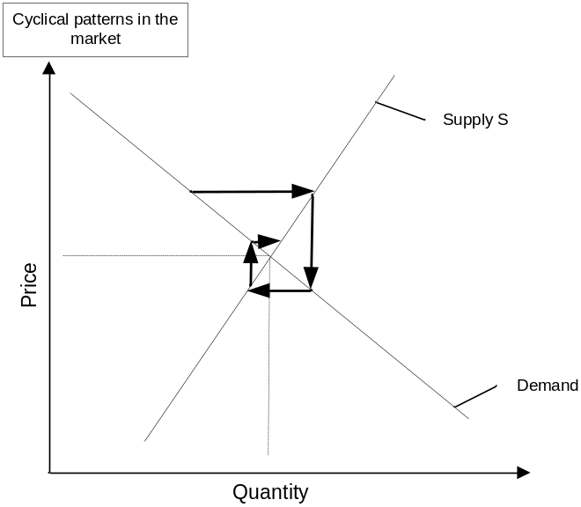

Module 6 Economic Efficiency

If producers specialize in what they can produce, the best way so that total output of an economy increases this is called division of labor. The total utility will be greater with trade or exchange occurring.

Marginal Equivalency
A utility maximizing consumer will allocate it’s income in a way that the Marginal Utility that a consumer gains from a good A relative to the price of that good is the same as the Marginal Utility for good B relative to the price of good B.
Since the Marginal Cost of a company to produce a good equals the price for that good if the company is competitive and profit maximizing it follows that if:
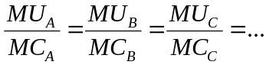
economic efficiency will prevail in the economy.

An industry is in equilibrium if no forces exist to cause change. That is the case if firms are making normal profits, average revenue (price) equals long run average cost (that includes normal profit) and no incentives for firms exist to either leave or enter the industry.

An economy is in general equilibrium if no forces exist that cause change. That implies, that no consumer wishes to change the spending pattern (they are already achieving maximal utility), and no firm is moving into or out of an industry.

Government intervention in a market economy is needed to move the economy to economic efficiency in the following areas:
- regulation and providing of public goods
- dealing with externalities
- dealing with the problem of economies of scale and the resulting monopolies
- adjustment of the income distribution if desired

Module 7 Organization of Industries

Industry Characteristic | Number of firms | Type of product | Barriers to entry | Control over price | Degree of Concentration | Example
Perfect Competition | Very Large | Homogeneous | None | None | Zero | Agricultural products, steel
Monopolistic/ imperfect competition | Large | Differentiated | None/ few | Some | Low | Restaurants, Clothes
Oligopoly | Small | Homogeneous | Scale | Substantial | High | Cars, Chemicals,
Monopoly | One | Unique | Scale or Legal | Complete | 100% | Public utilities

A perfectly competitive company is making above normal profits if the average revenue (price) exceeds the average cost. If above normal profits exist in an industry, resources will flow into that industry.

When no resources are moving from one industry to another each firm will be in the long run equilibrium, and price will be the long run marginal cost.

A monopolist is a producer that supplies the complete market for a good or service. The market supply curve is the short run marginal cost curve of the monopolist and the markets demand curve is the demand curve faced by the monopolist. Since the average revenue curve is the same as the demand curve and the demand curve is downward sloping, the marginal revenue curve will fall steeper than the average revenue curve. In comparison, the AR=MR and is a vertical line in a perfectly competitive industry.

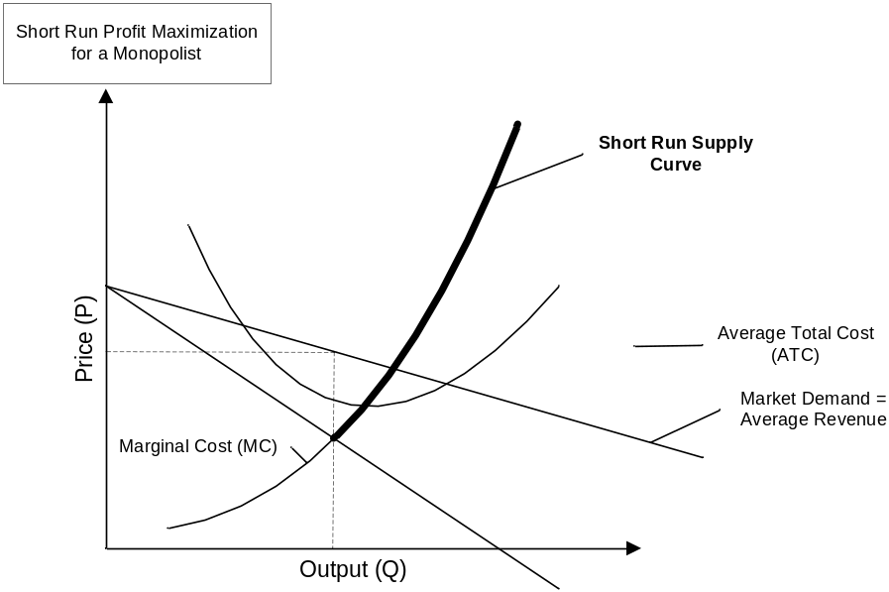

In the short run the monopolist will produce Q where MR=MC (short run equilibrium) but will be able to sell at a price P=AR, giving it a higher than normal profit since the price is above the marginal cost. The “fair” price (P=AR=MC) would have been lower and the monopolist would have produced more. However the monopolist would not have maximized profit at that point.

If the long run marginal cost (LRMC) is lower that the current marginal revenue a monopolist will expand. If the LMRC > MR the monopolist will decrease output. In both cases the (above normal) profits will increase in the long run. If a monopolist exists in an economy economic efficiency will not prevail as the marginal equivalency condition for all goods and services will not be reached (P is not equal MC thus the ratios of MU/MC are not all equal).

The main problem with a monopolist (from an economist’s point of view) is that the price of the good exceeds the marginal cost (including reasonable profit), thus the price that the consumer pays does not reflect accurately the marginal cost for society of producing that good.

It might be in a society’s interest to have a monopolist if economies of scale exist. In economies of scale the average cost of a good declines as output expands.

A monopolist can be regulated to achieve economic efficiency by
- setting the output and pricing strategy (e.g. through the government) to realize P=MC or by
- taxing a monopolists profit and subsidizing losses, thereby again aiming to achieve P=MC.
The problem with these suggestions is that they will not produce any incentives in the monopolist to operate efficiently.

Under imperfect competition fewer firms exist in a market, each faces a downward sloping demand curve (same as figure above for monopoly). Companies will move into the industry as long as above normal profits are earned and therefore the market supply curve will shift to the left. In the long run, equilibrium the average total cost will equal average revenue again, but companies have spare capacity, as they are not producing output at the minimum average total cost curve.

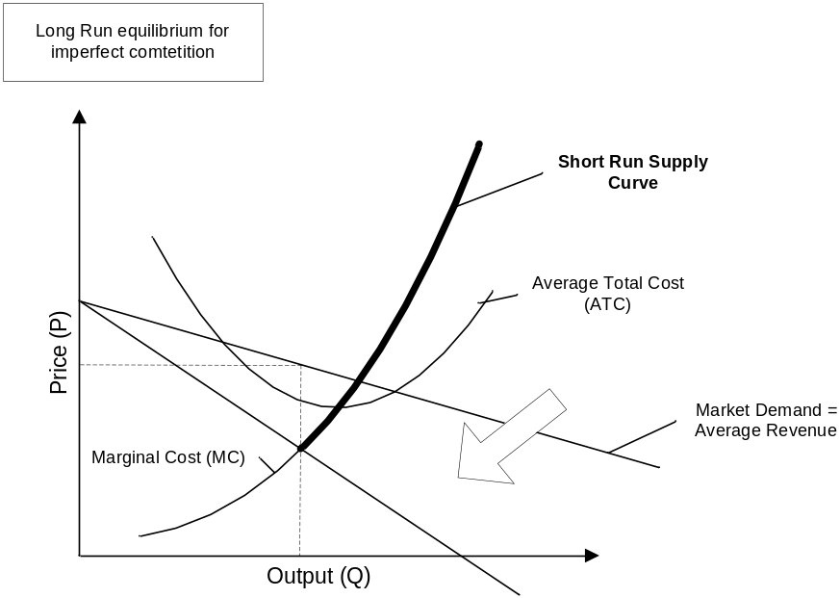

The principal agent problem describes a situation with a conflict of interest. An agent is an individual or a group of individuals to whom a principal has designated decision-making authority. However, the agent might not act in the best interest of the principal as he might have other (conflicting) interests. An example is the CEO is the agent of the board (principal) but might have his own and not the boards interest.

Module 8: Public Goods and Externalities

Reasons to not purely rely on market forces to determine the allocation of resources:
- Help to achieve economic efficiency when the market fails.
- Alter the distribution of goods and services to households

Economic equity distribution is the distribution of ownership of human and non-human capital. Economic efficiency and economic equity are separate concepts.

The market will not allocate resources in the most economic efficient way if
- The costs that firms pay for production of a good differ from the total production costs
- Some households can consume goods and services without having to pay for them

Private Good is a good or service for which each unit is consumed by only one individual or household. Characteristics:
  - Excludability: Only one household owns the right (for consumption) of that good.
  - Rivalry: If one household consumes a good there is less for other households left

Public Good is a good or service for which each unit is consumed by everyone and from which no individual can be excluded.

Many goods are not purely private or public goods.

The allocation for public goods cannot be achieved through market forces alone, due to the free rider problem.

A free rider is someone who consumes a good without having to pay for it.
Public goods require collective action by societies in order to produce them.

For a society to operate in an economic efficient way it needs to aim at allocating the resources at it’s disposal so that the marginal equivalency condition holds true.

Marginal Equivalency for a Society
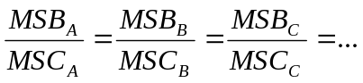
MSB is the marginal societal benefit
MSC is the marginal societal cost

Who pays for public goods? Two (extreme) methods could be used to determine that:
- If each household pays an equal amount for getting the same public good, the poor pay proportionally more of their income than the rich.
- If each household pays a fixed proportion on income, richer households would pay considerably more (in money terms) than poorer households.
Economic criteria cannot determine who should pay for a public good. That is a question of income distribution and thus consideration of equity.

Costs of production that are purely borne by the producing firm are private costs. Similarly, the benefit that a company considers if nobody else benefits from the good or service is a private benefit.

For economic activity where some costs are borne by a party not involved directly in the activity negative externalities or external costs are occurring. If benefits are received by a party not directly involved with the economic activity, positive externalities or external benefits occur.

When externalities exist, market prices will not lead to an efficient allocation of resources due to the divergence between private and societal costs/benefits. It requires collective action to achieve economic efficiency.

How can the problems that externalities produce be solved:
- Direct Government Legislation: If negative externalities exist in a market, a tax can be used to bring the market to the point of economic efficiency by ensuring that the buyer and seller take the tax on the transaction into account when making their decision. If a positive externality exists in a market that are not accounted for, a subsidy can be used to change the firms cost curve and thus the supply curve. This would decrease the price and increase the quantity, resulting in an accurate representation of the real benefit of the good/service. The government can also establish laws to regulate the externalities (e.g. pollution limits)
- The government can establish through indirect legislation clear property rights for the externalities. The producer or the affected are assigned the property right of the externality. They then can trade to the point where both are better off. The problem in this approach is often the prohibitive transaction and negotiation cost required.
- When external cost or benefits are brought within the scope of a single organization, the externalities are internalized.

Coase’s Theorem: in a situation with clearly defined property rights and external costs both parties can be better of if they account for negative externalities through negotiation and thus achieve economic efficiency (Example with the farmer and the rancher where the farmer pays the rancher for having less cattle graze and thus reducing the damage to the crop).

If collective decision-making to enable a “public choice” is performed using a voting process the voting paradox might lead to undesirable outcomes.

Module 9: Income Distribution

Gross National Product (GNP) is the value of the total output of goods and services produced by an economy in a year.

A way to compare the average materialistic well-being of a people in a country one can compare the GNP per capita at purchasing power parity (PPP). The PPP exchange rate compares the purchasing power of a currency for a representative basket of goods and services.

The value of the marginal product (VMP) shows the increase in value of the output for each additional factor input. The market demand curve for a factor input is the summation of all the VMP curves of the firms in that market. Profit maximizing firm will pay the equivalent of the value of the marginal product as the wage rate.

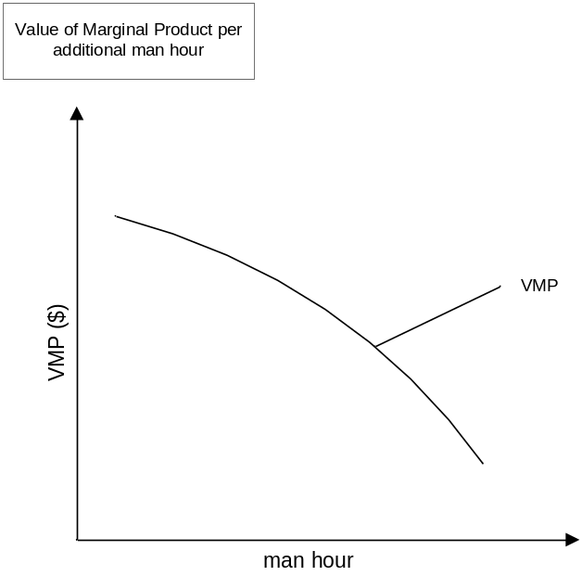

Economic Rent is the difference between the marginal product of a factor of production and the opportunity cost (the next best alternative use) for that factor. Example: In the market I might be able to get $100K for my services. My current contract pays me $80K. My next best alternative job would pay me $40K. The economic rent is $100K-$40K=$60K. The economic rent is divided 66% to me and 33% to my company due to my current contractual obligations. In a situation where the wage rate is less that the value of the marginal product of labor, labor is exploited.

Monopsony, the opposite of monopoly, means only one buyer in a market. It occurs when there is only one employer of factor inputs in a market.

The economic feature of a trade union is that it represents a group of, or all, resource owners in a market for factors of production.

A household below the poverty line earns insufficient income to support life adequately.

Income distribution in an economy and the economic efficiency of that economy are not related. The income distribution is a result of the distribution of economic equity. All market economies elect to alter the income distribution through transfer payments (e.g. taxes, payments in kind (welfare goods and services), etc.). One way to alter the income distribution is negative income tax. Using negative income tax the marginal tax rate for a household stays the same (or changes only very gradually) as the household moves from having no income, where he gets a maximum negative income tax from the government, to the point where he starts to pay income tax to the government.

How is economic equity distributed in different economic systems?
- Traditional economies: custom determines the allocation process with the most powerful member of society usually served first
- Command economies: wages and salaries are fixed by a central body as well as prices and quantities produced. The problem here is that supply might not match demand
- Market economies: competition for resources to produce goods and services determines price, consequently the income for the resource owners. People with little or no resources rely on charity by people with income, usually through government transfers.

Module 10: International Sector

The theory of absolute advantage (Adam Smith) states that if countries have an absolute advantage over the other country in the production of a good by using less labor and capital, both countries can benefit from trade with each other.

A country is said to have a comparative advantage in the production of a good if it can produce cloth at a lower opportunity cost than another country.

To prove the theory of comparative advantage (David Ricardo) assume a system in which:
- Only two goods are produced in each country initially
- Labor is the only variable factor but labor productivity differs
- Constant returns to scale (that is no productivity gains as the scale increases)
- Fully employed labor
- The productivity difference in one good between the two countries is not proportional to the productivity gap for the other good
- Resources are fully mobile within a country so that returns to equivalent labor and capital are equalized within a country
- The same resources are not internationally mobile
- No transportation cost
Under those assumptions two countries can still trade at an advantage to both of them. For details see http://internationalecon.com/v1.0/ch40/ch40.html.

Terms of Trade: The relative price of a country's exports compared to its imports.

Tariff: a tax imposed by an importing country when a good or service enters that country. Benefits the government and the protected industry.

Quota: a restriction specifying the maximum amount of a good that may enter a country during a specific time period. Protects a domestic industry without benefiting the government. A way to distribute the quota rights will have to be found. If the quota right were to be sold off, it would be worth the above normal profit.

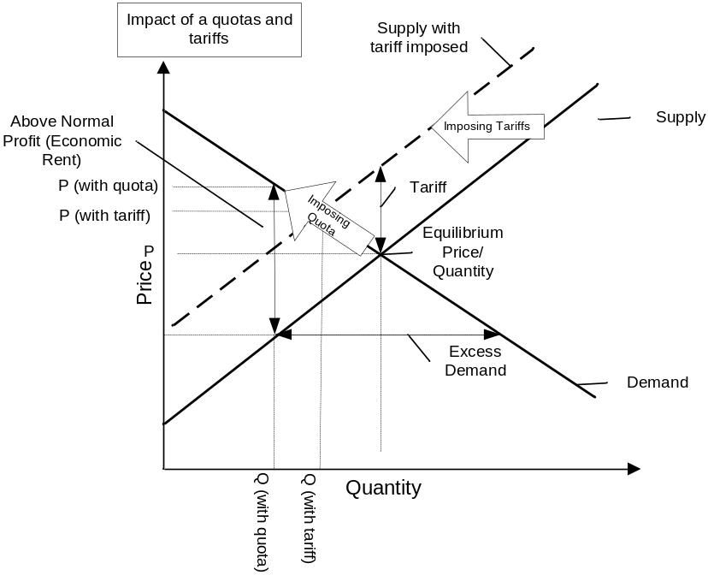

Voluntary export restraints: an agreement signed with the exporting nation to restrict the amount of imports.
Arguments for trade restrictions:
- Infant industry: As industries start to develop there has to be a period of protection to allow them to reach size and scale that is economically viable in the international competitive world.
- Dumping: Practice of selling a good in a foreign market at a lower price than prevails in the market of the exporting nation with the intent to drive the foreign company out of the market and then raise the prices. Dumping is considered illegal under international law.
- Countervailing duties: Tariffs imposed on imported goods produced by companies that receive production subsidies from their governments.

A county’s balance of payments account records its international trade, international borrowing, and its international lending.
The current account records all exports, imports of goods an services, and all other items that do not result in addition or subtraction on the countries claim on foreign resources
The capital account records all transactions that affect the amount of claims that a country has abroad and that other countries have in this county.

Current Account for Country X | $bn
Import of goods and services | 500
Exports of goods and services | 400
Current account balance | -100
Capital Account
Foreign investments in X | 300
X investments abroad | 190
Capital account balance | 110
Official settlements account
Change in official X reserves | 10
Net effect | 0

The balance of trade deficit or surplus is deficit of surplus in the current account for that country.
A balance of payment deficit (surplus) can be thought of as the excess supply (demand) of a countries currency that result from international transactions and that a country has to purchase (sell) in order to preserve the exchange rate. If the government does not buy the excess currency, the currency will depreciate and vice versa.
Factors affecting a Countries Exports (X):
- Foreign Demand or Foreign Income (Y_{F})
- Domestic Prices (P_{D}) versus Foreign Prices (P_{F})
Exchange Rate
Factors affecting a Countries Imports (Z):
- Domestic Demand or Domestic Income (Y_{D})
- Domestic Prices (P_{D}) versus Foreign Prices (P_{F})
- Exchange Rate

Version 1.0 on June 25, 2002

